**Introduction**

I am using FIFA 18 Soccer Data to present to "The Board" to build an all-star football team

**Overview of My Story**

I aim to convince the board of the feasibility and potential success of assembling an all-star football team. My presentation will focus on the talent and cost-effectiveness of potential player selections based on their performance stats.

**Visuals:**

**Visual 1: Best Defenders**

This bar chart displays the top defenders based on their average ratings, featuring players like G. Chiellini, A. Barzagli, J. Boateng, M. Hummels, Thiago Silva, and K. Koulibaly. It's designed to show "The Board" which defenders are most impressive and could enhance the team. The clear layout and consistent colors make it easy for the board to evaluate and understand the defensive options quickly. The visual is designed to ensure the data is easily readable, assisting the board in making well-informed decisions about which defenders to select. For the all-star team, I have chosen all six players because defense is crucial

**Visual 2: Best Goalkeeper:**

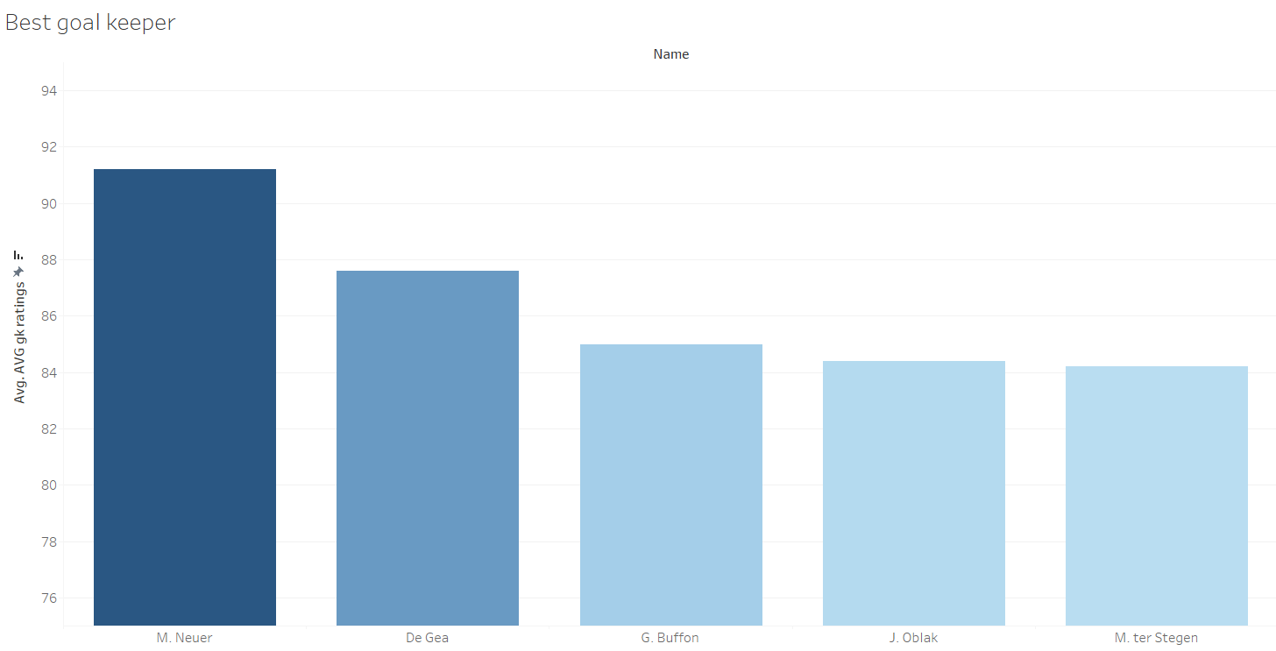

This bar chart compares top goalkeepers like M. Neuer, De Gea, G. Buffon, J. Oblak, and M. Ter Stegen based on their average ratings. It clearly shows M. Neuer's superior rating, highlighting his potential value for the all-star team. The blue color scheme helps keep the focus on the ratings, making it easy for "The Board" to see which goalkeeper stands out. This chart helps identify the best option for the goalkeeper position and sets a high standard for the team's defense. I have chosen the top goalkeeper because GK plays a crucial role.

**Visual 3: Best Strikers**

This bar chart compares top strikers such as Cristiano Ronaldo, L. Messi, G. Higuain, R. Lewandowski, and Z. Ibrahimovic based on their average shooting ratings. Cristiano Ronaldo stands out with the highest rating, showing exceptional scoring ability. The blue color scheme keeps the focus on the ratings, making it easy for "The Board" to understand. The chart highlights the key role these players can play in boosting the team’s offensive strength. Showcasing the top strikers emphasizes the importance of having strong goal scorers who can consistently deliver goals, aligning with the team’s goal of maintaining a powerful offense alongside a solid defense.

**Visual 4: My Players and Their Nationalities**

This treemap highlights the geographical diversity of the all-star football team, showcasing players from Germany, Italy, Argentina, Brazil, Poland, Portugal, and Senegal. Germany leads with the most players, underscoring the team’s strong European presence. Each segment's color distinction facilitates an easy understanding of the team’s global composition, reflecting its broad international appeal. This visual succinctly emphasizes the strategic advantage of leveraging international talent, aligning with the club’s goal of global competitiveness

Visual 5: My Players and Their Clubs

This treemap illustrates the club affiliations of the all-star football team members, with notable representation from FC Bayern Munich, Juventus, FC Barcelona, Napoli, Paris Saint-Germain, and Real Madrid CF. The large sections for FC Bayern Munich and Juventus indicate a significant number of players from these clubs, highlighting the team's strong foundation in top European football leagues. The color differentiation aids quick identification of each club, underscoring the strategic recruitment from internationally renowned teams. This visual effectively communicates the diverse club backgrounds of the players, aligning with the team's aim for a top-tier global presence.

**Visual 6: My Team Value**

This simple yet effective presentation shows that constructing the all-star football team would cost €636.0 million. This figure shows the total market value of all selected players, highlighting the team's high caliber and elite status. The large investment demonstrates the team's ability to play at the highest level, draw global attention, and create considerable returns from prizes and merchandise. Investing in such a top-tier team not only boosts the club's prestige but also offers significant financial and other benefits, creating a persuasive case for board support.

**Visual 7: ALL About My Team**

This detailed bar chart displays various attributes of key players in our all-star team, such as A. Barzagli, Cristiano Ronaldo, G. Chiellini, G. Higuain, and J. Boateng. Each player's abilities in areas like stamina, agility, vision, acceleration, sprint speed, strength, and goalkeeper handling are showcased. The chart highlights Cristiano Ronaldo's exceptional sprint speed and strength, while J. Boateng's agility and G. Chiellini's defensive handling are also emphasized. This visual allows the board to quickly assess the comprehensive skill sets of each player, reinforcing the team’s robust and versatile capabilities.

**Dashboards**

**Dashboard 1: All About My Team**

Dashboards

Dashboard 1: All About My Team

This dashboard displays key information about our all-star football team through several clear and organized charts. It includes the following sections:

• Best Goalkeepers: Shows M. Neuer as the leading goalkeeper.

• Best Defenders: Highlights G. Chiellini and J. Boateng for their defensive skills.

• Best Strikers: Put Cristiano Ronaldo at the top for his scoring ability.

• My Team Value: Indicates the team would cost €636.0 million to assemble.

The dashboard also shows player nationalities and their clubs, using color coding to easily identify different teams and countries. The layout is straightforward, with similar colors grouped and everything aligned neatly, both vertically and horizontally. This alignment, learned in class, ensures the information is easy to read and understand, making it clear and accessible for the audience.  
  
**Dashboard 2: Overall stats of the team:**

This bar chart shows the key attributes of our all-star players, including A. Barzagli, Cristiano Ronaldo, G. Chiellini, G. Higuain, and J. Boateng. It highlights their stamina, agility, vision, acceleration, sprint speed, strength, and goalkeeper handling. For example, Cristiano Ronaldo excels in sprint speed and strength, while J. Boateng is agile, and G. Chiellini is strong in defense. This chart helps the board see each player's skills.

I have added filters for all the attributes and players, allowing the board to select and compare players or specific skills. As I learned in class, this interactivity helps to understand everything about each player, aiding in making informed decisions about the team.

**Process of Visual Development**

I started by picking the team based on calculated fields, focussing on five critical skills for forwards, defenders, and goalkeepers. I averaged these abilities to determine the top players in each category, then used plots to select the 11 players: four forwards, six defenders, and one custodian. To determine if the players could work well together, I looked at their nationalities and clubs to see who had previously played together. This helped to assure the board that team cohesiveness would not be an issue. I then created a thorough bar chart that displayed key characteristics such as stamina, agility, vision, acceleration, sprint speed, and strength. This allowed the board to immediately understand each player's capabilities. Finally, I computed the team's overall market worth, which was €636.0 million, and designed a visual to demonstrate this investment to the board.

**Problems encountered**One problem was selecting defenders for precise roles. I required two center-blockers (CB), two left-blockers (LB), and two right-blockers (RB) to establish a robust defense. Another problem was balancing the high costs of players like Messi and Ronaldo, who would give the squad a significant edge.

**Audience Persona: "The Board"**

I designed my visuals for "The Board," a group of decision-makers responsible for approving the budget. The visuals were clear, informative, and persuasive, focusing on the players' strengths, team chemistry, and financial implications

**Outcomes**

The project resulted in well-structured visuals that effectively communicated to "The Board." I used interactive elements, like filters for attributes and players, which I learned in class, to help with detailed analysis. This interactivity was crucial for decision-making.

In conclusion, this project improved my skills in data visualization and storytelling. By applying what I learned in class and focusing on the needs of "The Board," I created a strong case for building an all-star football team. This experience showed the importance of aligning data presentations with the audience's expectations to ensure clarity and impact.